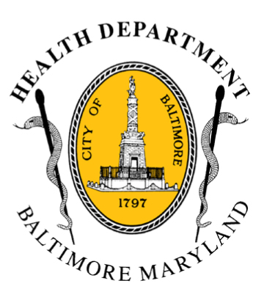
BCHD PRESS RELEASE
Baltimore City Health Department
1001 E. Fayette Street • Baltimore, Maryland 21202
Stephanie Rawlings-Blake, Mayor
Leana Wen, M.D., Commissioner of Health

FOR IMMEDIATE RELEASE
Media Contact: Michael Schwartzberg, PIO
O: (443) 984-2623 C: (443) 462-7939 E: michael.schwartzberg@baltimorecity.gov
Baltimore City Health Department Confirms Patient Being Evaluated
For Fever; No Danger To Public Suspected

BALTIMORE, MD (May 31, 2015) –The Baltimore City Health Department can confirm that a patient is undergoing evaluation at Johns Hopkins Hospital with a chief complaint of fever after recently returning from West Africa.

The patient is currently being treated in an isolation room. The initial evaluation is suggestive of a diagnosis other than Ebola infection but further tests are ongoing.

“The testing is being done out of an abundance of caution; all protocols have been followed for safe transport of the patient and the system is working as intended,” said Dr. Leana Wen, Baltimore City Health Commissioner. “There is no danger to the public at large.”

BCHD is working closely with Johns Hopkins Hospital doctors, Maryland Department of Health & Mental Hygiene, and the Centers for Disease Control.

Under standards established by the federal government, travelers from affected countries in West Africa are monitored and this evaluation is standard and follows all protocols.

###

